JavaScript Assignment #1

**Part 1: About Me**

[Page Your A1P1 Screenshot Here, then paste your code below it]

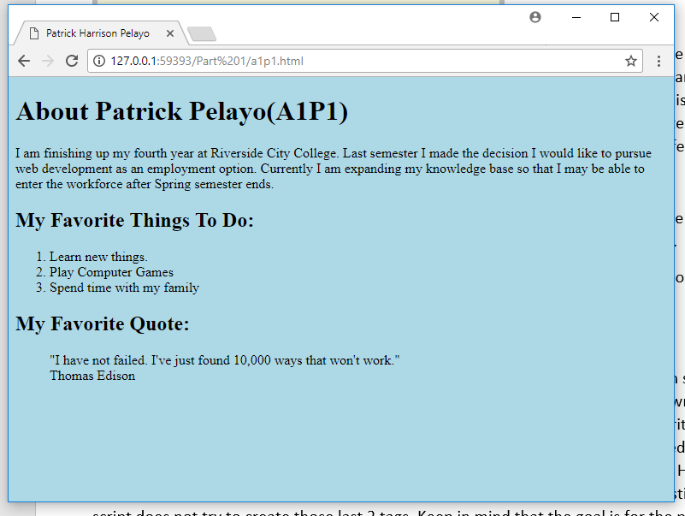

[Paste your A1P1 Code Here, Below the Screenshot]

<!DOCTYPE html>

<html lang="en">

<head>

<meta charset="utf-8">

<title>Patrick Harrison Pelayo</title>

</head>

<body style="background-color: lightblue">

<h1>About Patrick Pelayo(A1P1)</h1>

<p>I am finishing up my fourth year at Riverside City College. Last semester I made the decision I would like to pursue web development as an employment option. Currently I am expanding my knowledge base so that I may be able to enter the workforce after Spring semester ends.</p>

<h2>My Favorite Things To Do:</h2>

<ol>

<li>Learn new things.</li>

<li>Play Computer Games</li>

<li>Spend time with my family</li>

</ol>

<h2>My Favorite Quote:</h2>

<blockquote cite="https://www.forbes.com/sites/ekaterinawalter/2013/12/30/30-powerful-quotes-on-failure/#7d5f797524bd">"I have not failed. I've just found 10,000 ways that won't work."<br/>

Thomas Edison

</blockquote>

</body>

</html>

**Part 2: About Document.Write**

[Paste your part 2 code below]

<!DOCTYPE html>

<html lang="en">

<head>

<meta charset="utf-8">

<title>Patrick Harrison Pelayo</title>

</head>

<body style="background-color: lightblue">

<h1>About Patrick Pelayo(A1P2)</h1>

<p>I am finishing up my fourth year at Riverside City College. Last semester I made the decision I would like to pursue web development as an employment option. Currently I am expanding my knowledge base so that I may be able to enter the workforce sometime after spring semester has ended.</p>

<script>

document.write('<h2>My Favorite Things To Do:</h2>');

document.write('<ol><li>Learn new things.</li><li>Play Computer Games</li><li>Spend time with my family</li></ol>');

document.write('<h2>My Favorite Quote:</h2>');

document.write('<blockquote cite="https://www.forbes.com/sites/ekaterinawalter/2013/12/30/30-powerful-quotes-on-failure/#7d5f797524bd">"I have not failed. I\'ve just found 10,000 ways that won\'t work."<br/> Thomas Edison</blockquote>');

</script>

</body>

</html>

**Part 3: Temperature Conversion**

[Page Your A1P3 Screenshot Here, then paste your code below it]

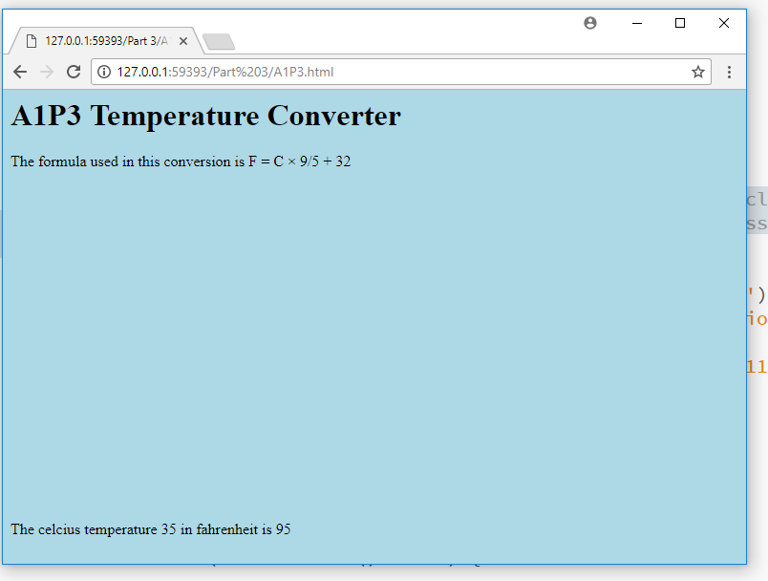

[Paste your A1P3 Code Here, Below the Screenshot]

<!DOCTYPE html>

<html lang="en">

<head>

<meta charset="utf-8">

<title>Patrick Pelayo's A1P3 Temperature Converter</title>

</head>

<body style="background-color: lightblue">

<h1>A1P3 Temperature Converter</h1>

<button onclick="convertC2F()">Click to begin conversion</button>

<script>

function convertC2F() {

var clicked = prompt('Enter celsius temperature to convert into fer.'),

repeat = true; //Flag for input validation do while loop

//will repeat every time a value is not acceptable

do {

//Input Validation

if (!(Number.isNaN(parseFloat(clicked)))) {

//clear repeat flag

repeat = false;

//convert string into float (if not the conversion clicked * (9/5) + 32 gives NAN when input "5 k" letters //after number breaks the conversion in below expression)

clicked = parseFloat(clicked);

document.write('<h1>A1P3 Temperature Converter</h1>');

document.write('<p>The formula used in this conversion is F = C × 9/5 + 32</p>');

document.write('<p style="position:absolute;bottom:11px">The celcius temperature ' + clicked + ' in fahrenheit is ');

document.write(clicked * (9 / 5) + 32, "</p>");

document.body.style.backgroundColor = "lightblue";

} else {

if (clicked.trim() != "") {

clicked = prompt("That is not a number.\nEnter celsius temperature to convert into fer. ");

} else {

clicked = prompt("No value was entered.\nEnter celsius temperature to convert into fer. ");

}

}

} while (repeat === true)

}

</script>

</body>

</html>

**Part 4: Alert -- It’s Freezing in Here!**

[Paste your part 4 code below]

<!DOCTYPE html>

<html lang="en">

<head>

<meta charset="utf-8">

<title>Patrick Pelayo's A1P4 Temperature Converter</title>

</head>

<body style="background-color: lightblue">

<h1>A1P4 Temperature Converter</h1>

<button onclick="convertC2F()">Click to begin conversion</button>

<script>

function convertC2F() {

var clicked = prompt('Enter celsius temperature to convert into fer.'),

repeat = true; //Flag for input validation do while loop

//will repeat every time a value is not acceptable

do {

//Do the conversion

if (!(Number.isNaN(parseFloat(clicked)))) {

//don't perform a loop

repeat = false;

//convert string into float (if not the conversion clicked * (9/5) + 32 gives NAN when input "5 k" letters //after number breaks the conversion in below expression)

clicked = parseFloat(clicked);

//redraw the background

document.write('<h1>A1P3 Temperature Converter</h1>');

document.write('<p>The formula used in this conversion is F = C × 9/5 + 32</p>');

document.body.style.background = "lightblue";

if (clicked > 32) {

window.alert(clicked + ' in celcius is ' + (clicked * (9 / 5) + 32) + ' in Feren.');

} else

window.alert(clicked + ' in celcius is ' + (clicked * (9 / 5) + 32) + ' in Feren and that is freezing cold!');

//Input validate when conversion is not acceptable

} else {

if (clicked.trim() != "") {

clicked = prompt("That is not a number.\nEnter celsius temperature to convert into fer. ");

} else {

clicked = prompt("No value was entered.\nEnter celsius temperature to convert into fer. ");

}

}

} while (repeat === true)

}

</script>

</body>

</html>